Classification of ECG Signal Severity in Patients Diagnosed with Atrial Fibrillation Using 1D CNN-LSTM Models
A Thesis Project
Presented to the
School of Information Technology
Mapua Institute of Technology
In Partial Fulfillment
of the Requirements for Thesis in Computer Science
By

Tambagan, Enrick Alfonzo
Neil Brags Guzman
Tolentino, Amable Joaquin III. B.
August 2025

TABLE OF CONTENTS

Chapter 1: INTRODUCTION ..................................................................................... 4
- 1.1 Context of the Study ......................................................4
- 1.2 The Problem, Gap, or Opportunity ................................5
- 1.3 Research Questions ........................................................6
- 1.4 Research Objectives .......................................................6
- 1.5 Significance of the Study ...............................................7
- 1.6 Scope and Limitations ...................................................9

Chapter 2: REVIEW OF RELATED LITERATURE & STUDIES .......................... 10
- 2.1 From Traditional Learning to Deep Learning...............................11
- 2.2 Hybrid Architectures: Combining CNN and LSTM .....................11
- 2.3 Handling Noise and Signal Processing ........................................12
- 2.4 Overview of Deep Learning Architectures .................................12
- 2.5 The Challenge of Real-Time Deployment ....................................13
- 2.6 Comparative Performance for ECG Anomaly Detection ..............14
- 2.7 Use of Transfer Learning ..........................................................14
- 2.8 Theoretical Framework..............................................................15
- 2.9 Deep Learning Approaches for ECG Arrhythmia Detection ........15
- 2.9.1 Hybrid CNN-LSTM Architectures for ECG Classification ........15
- Definitions and Key Concepts .........................................................16
- Mathematical Models and Algorithms ..............................................16
- Signal Preprocessing and Feature Extraction ....................................17
- Conceptual Framework ...................................................................19

Chapter 3: METHODOLOGY .................................................................................. 20
- 3.1 Data Collection and Preprocessing..........................................21
- 3.2 System Specifications..............................................................23
- 3.3 Conceptual Design and Rationale ...........................................25
- 3.4 Training the Model and Parameter Adjustment ......................26
- 3.5 Evaluating Model Performance ..............................................27
- 3.6 Validating and Testing.............................................................29
- 3.7 Deploying the Model and Making it Understandable.............29
- 3.8 Identifying Limitations and Planning Future Work................29
- 3.9 Ethical Considerations............................................................30
REFERENCES ............................................................................................................ 31

Chapter 1
INTRODUCTION
This chapter outlines the structure of the study. It begins with the clinical context of atrial fibrillation (AF) and its associated health risks, followed by an analysis of the current gaps in diagnosing its severity. It then presents the machine learning approach used to address these limitations and introduces the core research questions and objectives. Finally, the section details the significance, scope, and technical boundaries of the research.

Context of the Study
Atrial fibrillation (AF) is a major cardiovascular condition that increases risks for stroke and heart failure [1]. In computational cardiology, automating the severity classification of AF using electrocardiogram (ECG) signals is challenging because physiological signals are non-stationary, featuring highly variable R-R intervals and missing P-waves. Raw ECG data is also corrupted by baseline wander from respiration, 50/60 Hz power line interference, and electromyographic (EMG) artifacts from muscle movement [4]. A computational model must filter these noise types before extracting features.

To improve on shallow machine learning algorithms, this study uses a hybrid 1D CNN-LSTM architecture to classify AF signal severity. The model handles both spatial and temporal data dimensions, the 1D Convolutional Neural Network (CNN) extracts spatial features to isolate waveform shape anomalies, while the Long Short-Term Memory (LSTM) network captures sequential, long-range temporal dependencies of heart rhythms over time. Combining them allows the algorithm to output a specific severity classification instead of a simple binary detection. Currently, the clinical standard for classifying ECG results relies on manual interpretation of 12-lead ECGs or Holter monitor recordings by cardiologists using European Society of Cardiology (ESC) guidelines [3]. Specialists visually judge severity based on arrhythmic episode frequency, ventricular rate, and subjective symptom scores like the EHRA score. However, this manual approach is time-intensive, does not scale for continuous remote monitoring, and is susceptible to inter-observer variability [6, 7].

The Problem, Gap, or Opportunity
Most deep learning research focuses on binary anomaly detection (normal vs. abnormal). This leaves a gap because clinical decisions require classifying cardiac anomalies into mild, moderate, and severe categories to determine treatment urgency. Compounding this, a lack of standardized severity labels in large public datasets restricts their immediate usefulness for deep clinical research.

The methodology in previous works is also poorly explained. While many publications describe their model performance, they do not explain the physiological reason why a CNN-LSTM hybrid fits ECG signals, specifically how it maps to the data's dual temporal (rhythm sequence) and spatial (waveform shape) traits. Furthermore, previous research frequently relies on accuracy as the sole performance metric. This metric is inadequate in medical settings where clinical reliability is better captured by precision, recall, F1-score, and ROC-AUC. Finally, little research bridges the gap between algorithm development and clinical utility by integrating these models into a user-interface proof of concept.

Furthermore, validating model performance typically requires access to an independent panel of medical experts to verify predictions. To address this challenge without local clinical specialists, this study relies on pre-certified medical annotations and international regulatory testing criteria as an algorithmic validation baseline.

Research Questions
- How effective is a hybrid 1D CNN-LSTM model in classifying the severity of ECG signals compared to existing single-architecture methods?
- Which evaluation metrics (accuracy, precision, recall, F1-score, and ROC-AUC) best reflect the model's clinical reliability and performance?

Research Objectives
The primary goal of this study is to develop and evaluate a 1D CNN-LSTM model for classifying the severity of ECG signals by leveraging both the spatial and temporal properties of the waveform.

In particular, this research aims to:
- Develop a CNN-LSTM model capable of classifying ECG signals into severity levels (normal, mild, severe) and benchmark its performance against existing deep learning baselines.
- Evaluate clinical reliability using specific performance metrics tailored for diagnostic workflows:
  - Recall (Sensitivity): To measure the model's capacity to correctly identify positive atrial fibrillation cases, ensuring critical cardiac risks are not missed.
  - Precision: To assess positive prediction accuracy, minimizing false alarms that trigger clinical fatigue or unnecessary treatment.
  - F1-Score: To provide a balanced metric between precision and recall, which is vital when working with imbalanced datasets where normal rhythms outnumber arrhythmic events.
  - ROC-AUC: To determine the model’s overall capability to distinguish between different severity levels across various decision thresholds.

Significance of the Study
This study addresses shortcomings in ECG analysis by shifting focus from simple arrhythmia detection to actionable severity classification. By introducing a hybrid 1D CNN-LSTM model, the research provides an automated diagnostic tool that mirrors clinical decision-making needs.

From a technical perspective, this paper provides a systematic rationale for using hybrid architectures on physiological signals. It demonstrates how a CNN’s spatial feature extraction blends with an LSTM’s temporal tracking to handle complex waveforms. The inclusion of a proof-of-concept graphical user interface (GUI) demonstrates how deep learning models can transition into practical diagnostic tools. In environments with limited access to specialists, such systems can improve workflow efficiency, shorten interpretation times, and stabilize diagnostic consistency.

The validation framework eliminates the need for real-time specialist review by inheriting a pre-certified, peer-reviewed clinical ground truth directly from the source dataset infrastructure. Aligning the model output with recognized regulatory evaluation protocols ensures that the validation pipeline adheres strictly to established medical standard testing methodologies.

Scope and Limitations
This study focuses on classifying the severity of atrial fibrillation signals using single-lead recordings, which are standard for rhythm interpretation. The scope covers data preparation, model construction, training, validation, and multi-metric evaluation. A proof-of-concept GUI is also developed to demonstrate practical clinical deployment.

Initial experiments rely strictly on public ECG datasets. Consequently, the study faces clear limitations: the data does not account for patient-specific variables such as age, comorbidities, concurrent medications, or long-term disease progression. Furthermore, this system functions purely as a clinical decision-support tool, it is not tested in real-time clinical environments and is not intended to replace expert medical judgment.

Chapter 2

REVIEW OF RELATED LITERATURE & STUDIES
This chapter outlines current deep learning developments in electrocardiogram (ECG) arrhythmia detection and cardiovascular analysis. It examines how combining convolutional and recurrent networks improves feature isolation and processing efficiency. The following sections address key signal challenges including environmental interference, dataset imbalances, and automated feature mapping while establishing baseline performance metrics across deep learning architectures.

A comprehensive review of automated cardiac classification shows that deep learning models consistently outperform traditional statistical methods. For example, a hybrid architecture combining a Convolutional Neural Network (CNN) with a Long Short-Term Memory (LSTM) network improves classification accuracy across multiple cardiac irregularities This framework uses the CNN block to automate spatial feature extraction from waveform shapes while the LSTM layers track historical temporal intervals. This combined processing method resolves both localized heartbeats and broad rhythm variations, making it a reliable choice for identifying distinct stages of atrial fibrillation.

From Traditional Learning to Deep Learning
Cardiovascular disease detection has moved beyond traditional machine learning frameworks. Older statistical methods like logistic regression lacked the sensitivity needed to capture complex patterns in raw ECG data. Modern frameworks have largely shifted to deep learning. Architectures like CNNs and RNNs consistently outperform shallow algorithms because they automate feature extraction, removing the biases and limitations of manual input.

Hybrid Architectures: Combining CNN and LSTM
Single-architecture models often fail to capture the full complexity of ECG signals. To address this, recent studies rely on hybrid models to combine complementary network strengths. Combining CNNs with Long Short-Term Memory (LSTM) networks is highly effective for arrhythmia classification. In this configuration, the CNN extracts spatial features, such as QRS complex shape, while the LSTM layers process the timing and sequence of the heartbeats over time.

Researchers implement these hybrids based on competing optimization goals. Some focus strictly on efficiency, for example, lightweight CNN-LSTM architectures are designed to reduce parameters for edge-device deployment without losing accuracy [8]. Others prioritize clinical trust by integrating explainable AI (XAI) elements into the hybrid architecture, ensuring the diagnostic logic is transparent to medical professionals rather than acting as an uninterpretable black box [9]. This division highlights the engineering trade-off between building fast models for wearables and highly interpretable models for clinical validation.

Handling Noise and Signal Processing
Because real-time ECG data collection is inherently noisy, data quality remains a critical hurdle. One approach integrates Sigma-Delta Modulation (SDM) directly with CNNs to reduce noise before the data enters classification layers, preserving downstream feature accuracy.
Another methodology alters the data representation by converting 1D ECG signals into 2D time-frequency images using Morse wavelets. This transformation allows researchers to apply transfer learning using pre-trained image classification models like ResNet-50 [2]. However, while this signal-to-image approach yields high classification accuracy, it is significantly heavier computationally than processing 1D arrays directly.

Overview of Deep Learning Architectures
Deep learning models for ECG arrhythmia classification span a variety of structural styles, including CNNs, Multi-Layer Perceptrons (MLPs), RNNs, and Transformers [10]. Comparisons highlight distinct trade-offs regarding precision, computational latency, and memory footprint. For instance, 1D CNNs optimized with Adam and using sparse categorical cross-entropy provide multi-class identification when coupled with normalization and dropout layers to prevent overfitting on noisy records. While Transformer models are increasingly used due to their superior capability in learning long-range dependencies in sequential data, their high computational overhead makes them less practical for resource-constrained environments than hybrid CNN-LSTMs.

The Challenge of Real-Time Deployment
Running complex deep learning models on resource-constrained edge devices or wearables remains an engineering challenge. While real-time edge processing for atrial fibrillation is feasible, it requires highly optimized architectures. Although Transformer models handle long-range historical data well, their high computational cost makes them less practical for real-time monitoring devices compared to highly efficient CNN-LSTM hybrids.
- Comparative Performance for ECG Anomaly Detection
Cross-dataset performance evaluations indicate that while Transformers, RNNs, and CNNs can achieve comparable peak accuracy, CNN-based architectures are significantly more efficient computationally. To improve portability across diverse patient datasets and reduce overfitting, developers frequently use regularization techniques such as targeted dropout layers within the CNN blocks.

- Use of Transfer Learning
Transfer learning approaches leverage networks pre-trained on large image datasets (e.g., AlexNet, ResNet-50) by fine-tuning them on ECG data that has been converted into 2D time-frequency representations. This methodology speeds up convergence and can achieve excellent classification accuracy. It directly addresses data scarcity issues common in medical studies, though it increases the initial computational footprint during data transformation.

- Theoretical Framework
The theoretical framework of this study synthesizes automatic anomaly detection and supervised classification models within time-series analysis. It connects signal preprocessing, local spatial feature extraction, and gated temporal recurrence to establish a unified diagnostic pipeline.

- Deep Learning Approaches for ECH Arrhythmia Detection
Deep learning frameworks consistently outperform traditional machine learning techniques because they eliminate manual feature extraction. By directly feeding raw or filtered physiological signals into deep layers, the networks learn hierarchical representations of complex arrhythmias like atrial fibrillation natively.

- Hybrid CNN-LSTM Architectures for ECG Classification
Hybrid CNN-LSTM architectures map directly to the physical characteristics of ECG waveforms. The CNN layers isolate localized beat characteristics and spatial shapes, while the LSTM layers process these features sequentially to map long-range rhythm variations. This specific structural pairing is what enables the model to look beyond binary classification and differentiate granular severity levels in atrial fibrillation.

Definitions and Key Concepts:
- Arrhythmia Severity Classification: Arrhythmia is an irregular heart rhythm that deviates from standard cardiac physiology. This study focuses on classifying these detected deviations into distinct, clinically actionable severity categories.

Mathematical Models and Algorithms:
- Convolutional Neural Networks (CNNs): CNNs capture local spatial patterns in the ECG signal by applying convolutional operations to extract morphological features. The mathematical convolution of a continuous input signal $f$ and a filter kernel $g$ is defined as:
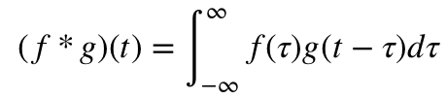

- Recurrent Neural Networks (RNNs) - RNNs are designed to process sequential time-series data where temporal order is critical. Unlike feedforward networks, RNNs utilize recurrent loops to pass historical information across timesteps, updating an internal hidden state $h_{t}$. In a standard vanilla RNN layer, the hidden state update is governed by the following recurrence equation: 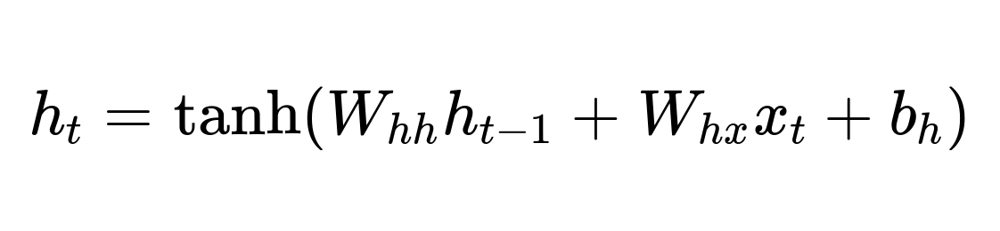
Where $W_{hh}$and $W_{hx}$ represent the weight matrices for the recurrent and input connections, $b_{h}$ is the bias vector, and $tanh$ is the hyperbolic tangent activation function. Because standard RNNs suffer from vanishing and exploding gradients over long ECG strips, this framework implements Long Short-Term Memory (LSTM) networks. LSTMs introduce a cell state $C_{t}$ controlled by three gating mechanisms, the forget gate $f_{t}$, input gate $i_{t}$, and output gate $o_{t}$, to regulate information flow and preserve long-term historical dependencies:
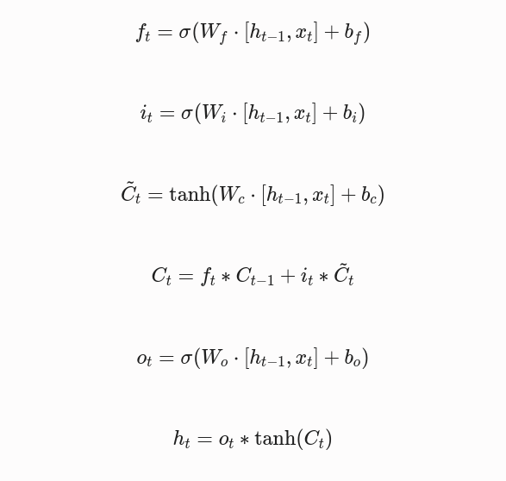

- Transfer Learning with Pre-trained Models: Transfer learning adapts heavy architectures (AlexNet, ResNet-50) to ECG classification tasks. Fine-tuning these models on targeted ECG data allows developers to leverage established feature-extraction hierarchies without consuming massive computational training resources.

Signal Preprocessing and Feature Extraction
Preprocessing prevents downstream classification bias through two primary steps:
- Noise Reduction: Applies band-pass filtering and wavelet transformations (such as the Morse wavelet) to eliminate baseline wander and powerline interference.
- Signal-to-Image Transformation: Translates a 1D time-series ECG signal into a 2D spectrogram or time-frequency representation, enabling spatial feature extraction via 2D deep learning architectures.

Chapter 3
METHODOLOGY
The proposed multi-stage diagnostic pipeline handles everything from raw signal acquisition to final interface deployment. The framework evaluates performance across multiple model architectures to isolate the most clinically reliable configuration.

Data Collection and Preprocessing

The dataset for this study is sourced from the Icentia11k database to establish an evaluation cohort containing both pathological and control records.

Icentia11k Database: This dataset serves as the single source for both atrial fibrillation and normal sinus rhythm recordings, providing large-scale continuous ECG data.

Filtering: Raw signals are passed through band-pass filters to eliminate low-frequency baseline wander and high-frequency noise from muscle artifacts or powerlines.

Segmentation: Continuous recordings are segmented into equal, non-overlapping 2-second windows to isolate brief cardiac periods.

Normalization: Signal amplitudes within each segment are scaled between 0 and 1 via Min-Max Normalization. This step homogenizes differences caused by patient physiology or varying electrode impedance, ensuring stable network convergence.

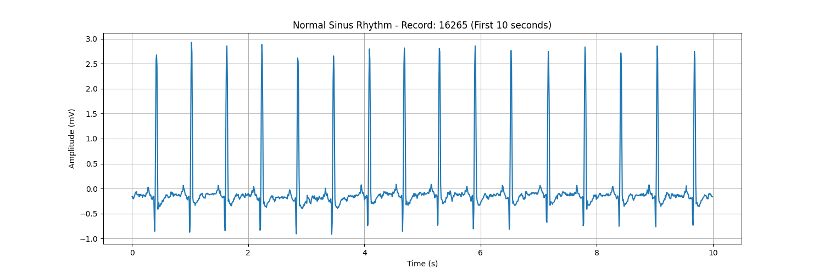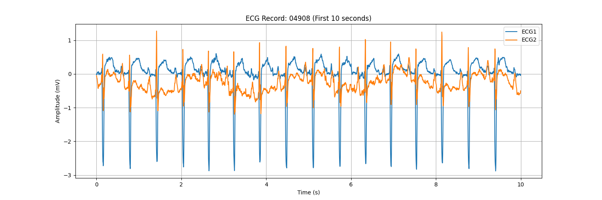

Figure 1. Example ECG Signals. (A) A 10-second segment illustrating a typical Normal Sinus Rhythm from the nsrdb. (B) A 10-second segment showing a characteristic Atrial Fibrillation rhythm from the afdb.

System Specifications

The hybrid 1D CNN-LSTM model eliminates traditional manual feature engineering. The 1D CNN layers act as native feature detectors, automatically isolating local waveform morphologies like QRS complex architecture. The subsequent LSTM layers receive these feature maps sequentially to evaluate temporal properties, such as the beat-to-beat variability of R-R intervals.

Hardware Environment
- Processor & Graphics: Apple M3 Pro chip (incorporating unified CPU and GPU architectures), leveraged to accelerate tensor math and handle parallel training batches.
- Memory: 18 GB Unified Memory, matching processing demands for data segmentation and model training.
- Storage: 512 GB SSD, selected to maintain high read/write speeds during batch operations.

Software Stack
- Operating System: macOS
- Environment & Core Language: Python 3.10
- Core DL Framework: TensorFlow (Keras API) or PyTorch, with Apple Silicon GPU acceleration.
- Processing & Analytics Libraries: NumPy and Pandas for mathematical array transformations; Scikit-learn for dataset partitioning, scaling, and metric tracking; Matplotlib and Seaborn for plotting loss curves and confusion matrices.

Conceptual Design and Rationale

The 2-Second Segmentation Window: Analyzing ECG signals requires balancing context length with computational efficiency. A 2-second window captures roughly 2 to 4 complete cardiac cycles. This duration provides sufficient sequential data to identify rhythm irregularities, such as the "irregularly irregular" R-R intervals of AF, while remaining compact enough to allow near real-time processing.

Min-Max Normalization: Neural networks are sensitive to input feature scales. Normalizing the waveform amplitudes ensures the model focuses entirely on the geometry and shape of the wave rather than absolute voltage variances across different patients.

The Spatial-Temporal Hybrid Hypothesis: Standard networks fail when restricted to a single dimension. A 1D CNN acts as the spatial sensor, scanning localized sub-segments to identify discrete structural details like QRS shapes. The LSTM functions as the temporal memory tracker, analyzing how those spatial feature maps shift over time to evaluate the systemic cardiac rhythm.

Training the Model and Parameter Adjustment

Data Partitioning: The processed dataset is divided into a strict 70% training, 15% validation, and 15% testing split to guard against data leakage and verify generalization.

Loss Function and Optimization: Multi-class severity categorization is optimized using categorical cross-entropy loss. The network adjusts weights via the Adam optimizer, utilizing its adaptive learning rate properties to avoid local traps.

Hyperparameter Tuning: To stabilize the network, an empirical grid search was conducted across the following parameter bounds:

Learning Rate: Initialized at 0.001 to ensure steady gradient descent.

Batch Size: Configured to 64 to fully saturate computing memory bandwidth while maintaining enough stochastic gradient noise to prevent early traps.

CNN Filter Density: Set to 64 filters in the primary convolutional layer to resolve spatial features across windows.

LSTM Hidden Units: Capped at 64 units to capture 2-second dependencies without inducing training set overfitting.

Dropout Rate: Set to 0.3 across dense layers to randomly deactivate nodes during training, forcing the network to learn generalized patterns.

Evaluating Model Performance
The evaluation framework directly answers the research questions outlined in Chapter 1. Because this study does not utilize a local panel of cardiologists to manually verify individual results and discussions, model accuracy and reliability are validated through two objective criteria:

- Pre-Certified Ground Truth Annotations: [15] The model uses the Icentia11k database hosted by PhysioNet, which provides an established, clinically validated baseline. The dataset is processed from data provided by 11,000 patients who used the CartioSTAT device predominantly in Ontario, Canada, from various medical centers. The raw recordings in this dataset were captured using clinical-grade hardware and underwent full-disclosure analysis by an engineering and technical team. Every beat and rhythm annotation was independently audited, corrected, and approved by technical specialists before dataset publication. Utilizing this infrastructure allows the training and testing phases to directly inherit a verified clinical ground truth.

- Adherence to Certified Medical Standards: The classification schemas and performance evaluation criteria align with the ANSI/AAMI EC57 guidelines for testing cardiac monitors. These industry standards regulate how medical device manufacturers benchmark automated arrhythmia detection algorithms. Mapping model classifications and error metrics to these standardized criteria ensures the validation pipeline operates within a regulated medical engineering framework.

Metrics Pipeline

Assessing Global Performance: Global model capability is measured using Overall Accuracy and ROC-AUC scores. While accuracy offers a simple baseline comparison against traditional methods, class-specific ROC-AUC curves verify that the model maintains discriminative power across varying decision thresholds on imbalanced data.

Establishing Clinical Reliability: In a clinical context, reliability means minimizing diagnostic errors like false negatives and false positives. We prioritize three specific metrics over simple accuracy:
  - Recall (Sensitivity): Tracking the capacity to catch true positive cases to prevent undiagnosed cardiac incidents.
  - Precision: Measuring prediction accuracy to minimize false alarms and lower clinical alarm fatigue.
  - F1-Score: Calculating the harmonic mean of precision and recall to verify unbiased performance across imbalanced categories.

- Granular Error Analysis: A Confusion Matrix is generated to pinpoint exactly where the model struggles, specifically whether misclassifications occur between neighboring severity tiers (e.g., Normal vs. Mild AF) or distinct poles (Mild vs. Severe AF).

Validating and Testing

Cross-Validation: The stability of the network is verified using a k-fold cross-validation scheme to confirm that predictions remain stable across different data splits.

External Validation: Where accessible, the model is evaluated against unseen external datasets to verify that its feature extraction rules generalize beyond the training environment.

Deploying the Model and Making it Understandable

Deployment Pipeline: Validated models are compiled into optimized, low-latency deployment formats, such as TensorFlow Lite for mobile apps or prepared for hospital server deployment.

Model Interpretability (XAI): To establish clinical trust, the pipeline integrates visual interpretability layers like Grad-CAM or feature importance maps. These tools visually highlight which specific segments of the ECG waveform triggered the severity classification, helping clinicians understand model decisions. predictions.

Identifying Limitations and Planning Future Work

Limitations: The current architecture is bounded by challenges like a small sample size or lack of diversity within the dataset, which limits global model validation.

Future Work: Future research focuses on expanding the dataset, trying different architectures, or testing the model in real-world clinical environments.

Ethical Considerations

This study utilizes secondary, de-identified electrocardiogram records from the Icentia11k database via PhysioNet. Data access was formalized under the respective data use agreement. The research team maintained all files within secure local storage environments and made no attempts to re-identify any patient records.

Because the dataset is fully retrospective and lacks personal identifiers, this study involves no direct human subject interaction. It qualifies for an exemption from institutional ethical reviews or individual informed consent collection. Crucially, this software framework is designed strictly as a clinical decision-support tool; it is engineered to assist medical professionals, not to replace expert diagnostic human judgment.

Chapter 4
RESULTS AND DISCUSSIONS
-anyone

Chapter 5
CONCLUSION
-anyone

REFERENCES
[1] Dominique, V. M. H., Hans-Peter, B.-L. R., Dirk, J. V. V., & Kevin, V. (2021). The bidirectional interaction between atrial fibrillation and heart failure: consequences for the management of both diseases. EP Europace, 23(Supplement_2), ii40-ii45.
[2] Bodzas, A., Kodytek, P., & Zydeco, J. (2020). Automated detection of acute lymphoblastic leukemia from microscopic images based on human visual perception. Frontiers in Bioengineering and Biotechnology, 8, 1005.
[3] Rafie, N., Kashou, A. H., & Noseworthy, P. A. (2021). ECG Interpretation: Clinical Relevance, Challenges, and Advances. Hearts, 2(4), 505-513.
[4] Rjoob, K., Bond, R., Finlay, D., McGilligan, V., Leslie, S. J., Rababah, A., ... & Peace, A. (2020). Machine learning techniques for detecting electrode misplacement and interchanges when recording ECGs: a systematic review and meta-analysis. Journal of Electrocardiology, 62, 116-123.
[5] Rehman, M., & Rehman, N. U. (2020). Precordial ECG lead mispositioning: its incidence and estimated cost to healthcare. Cureus, 12(7).
[6] Kazanskiy, N. L., Khonina, S. N., & Butt, M. A. (2024). A review on flexible wearables—Recent developments in non-invasive continuous health monitoring. Sensors and Actuators A: Physical, 365, 114993.

[7] Rentz, L. E., Ulman, H. K., & Galster, S. M. (2021). Deconstructing Commercial Wearable Technology: Contributions toward Accurate and Free-Living Monitoring of Sleep. Sensors, 21(15), 5071.
[8] Obeidat, Y., & Alqudah, A. M. (2021). A hybrid lightweight 1D CNN-LSTM architecture for automated ECG beat-wise classification. Traitement du Signal, 38(5).
[9] Alamatsaz, N., Tabatabaei, L., Yazdchi, M., Payan, H., & Nasimi, F. (2023). A lightweight hybrid CNN-LSTM explainable model for ECG-based arrhythmia detection. Biomedical Signal Processing and Control, 90, 105884.
[10] Zhang, T. (2021). Arrhythmia classification based on CNN and LSTM_ATTENTION hybrid model. IEEE Conference Publication, IEEE Xplore.
[11] Karri, M., Annavarapu, C. S. R., & Pedapenki, K. K. (2022). A Real-Time cardiac arrhythmia classification using hybrid combination of Delta modulation, 1D-CNN and blended LSTM. Neural Processing Letters, 55(2), 1499-1526.
[12] Nordin, P. (2022). Modeling and evaluating an intelligent health monitoring system for atrial fibrillation detection (Doctoral dissertation, DIVA).
[13] Ansari, Y., Mourad, O., Qaraqe, K., & Serpedin, E. (2023). Deep learning for ECG Arrhythmia detection and classification: an overview of progress for period 2017-2023. Frontiers in Physiology, 14.
[14] Daydulo, Y. D., Thamineni, B. L., & Dawud, A. A. (2023). Cardiac arrhythmia detection using deep learning approach and time frequency representation of ECG signals. BMC Medical Informatics and Decision Making, 23(1).
[15] Tan, S., et al. (2019). Icentia11k: An unsupervised representation learning dataset for arrhythmia detection. PhysioNet.

